Getting your images out of the camera

When your camera takes a shot it is saved on to the memory card. We have mentioned before that you should take your shots in as large a format as your camera will allow and use a LARGE memory card. Memory cards are cheap, buy a big one or even two, and don’t run out of memory!

In 99% of cameras, images are saved using a format called JPEG. This is a universally recognised format and if you are interested in it’s origin consult the appendix on the subject.

Many people hold their images on their memory card and use their camera as an instrument to show family and friends their work however this is both inefficient and dangerous.
Inefficient because any image is only as good as the medium on which it is viewed, even Sharon Stone looks ordinary on a 16” black and white television!
Dangerous because (a) memory cards can and do get corrupted and (b) since you will have to delete some shots to make room for new ones you may accidentally delete an irreplaceable image. Worse still, it is not unheard of, for a photographer to accidentally press format and delete all images from the camera.

Downloading your images to a personal computer (PC) or laptop.

This can be done in a variety of ways and most cameras come with a CD which helps the user connect the camera to the computer however I have always found a simple card reader costing between €2 and €10 to be a very handy and simple tool. It is connected to the computer using a USB connection and appears as an extra drive on your computer.
Bear in mind that with modern computers there are generally a multitude of ways to get the same result so I have chosen what I believe to be the most simple and straight forward. When I refer to a PC I refer to any Windows based personal computer (PC) or laptop. In class we are using Windows XP but there are only small variations when other Windows versions are used.

A PC is basically a filing cabinet. To look at our files click on START and MY COMPUTER. Here we will see a number of “drives”, the one called C is generally the main “filing cabinet” D or E may be the drive for a CD or DVD and there may be any amount of other drives attached. When we insert the USB connection of our card reader a new drive will appear and will take as it’s name the next free letter of the alphabet. If you insert a multi-card reader you may see several new drives appear – one for each slot in your card reader.

(1) Decide where you want to put your photos, most PCs have a ready made file called “My Pictures” and you can use that if you like. I generally like to make a new folder on a main drive and create sub-folders within that folder named by date. So if you want your pictures to be on your C drive click on the C Drive icon on your screen. A list of files that reside on the C drive will appear and C:\ will appear in the address bar at the top of your screen.

(2) Click on that C:\ and make sure it goes blue. Now click on “file” on the top left menu, then “new” then “folder”. A new file called “new folder” will be added to the list on that drive. The words “new folder” will be blue denoting that the name is in editable mode. Just type the name you would like to call your main folder say “Mary’s pictures” press the “Enter” or “Return” key or simply click away from the file. You now have your very own file or filing cabinet on the PC into which you may put your images.
(3) You can download your images into this file right away but I would advise to do some housekeeping first and create sub-folders within your new file which you have named “Mary’s pictures”. To do this is almost a repeat performance of the above procedure. Click on the folder called “Mary’s pictures”. “C:\Mary’s pictures” will appear in the address bar at the top of your screen.
(4) Click on that “C:\Mary’s pictures” and make sure it goes blue. Now click on “file” on the top left menu, then “new” then “folder”. A new file called “new folder” will be added to the list on that drive. The words “new folder” will be blue denoting that the name is in editable mode. Just type the name you would like to call your new folder say “2009-11” press the “Enter” or “Return” key or simply click away from the file. Now we have created a file called “2009-11” which is a sub-folder within the file which we called “Mary’s pictures”.

You can repeat this procedure again and again and eventually you will have loads of sub-folders nestling inside the folder called “Mary’s pictures”. I always keep mine in date order so I will call my December file 2009-12, my January file 2010-01 and so on. If you need two or more files in any one month just add the day on to the end, e.g. 2009-12-25 will be the Christmas snaps. Of course you can ignore all this advice and just call the files “Tommy’s birthday” or whatever makes sense to you since we will be explaining later how to put files into date order anyway.

To download pictures (files) from your memory card in to your new file called “2009-11”.
(5) Insert your memory card into the card reader, after a few seconds the following dialog box will appear:

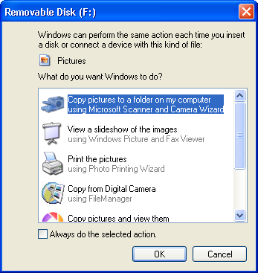

(6) Select the option “Copy pictures to a folder on my computer using Microsoft Scanner and Camera Wizard” and press “OK”. The screen below will appear so click “Next”

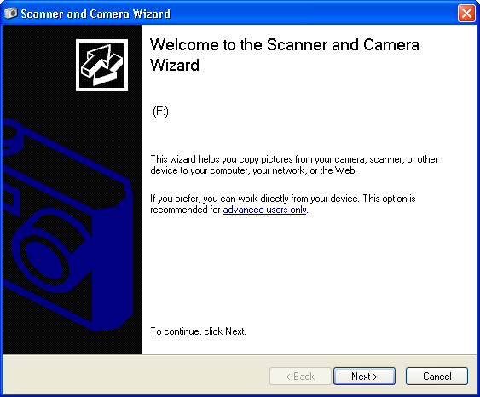

(7) A screen will open showing the images on your memory card, choose the ones you wish to transfer by putting a check mark in the boxes. There is an option to “select all” or “Clear all” check marks or you can check them one by one. I find it’s usually best to check and transfer the lot, as it’s quite easy to delete the rubbish from your computer. Then click “Next”

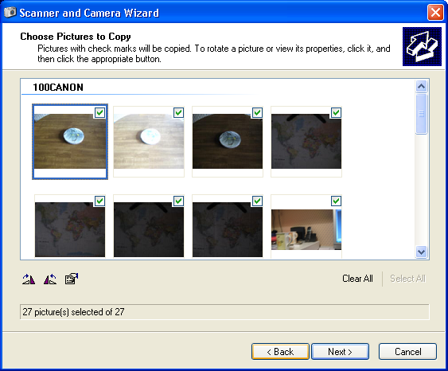

(8) You now come to a screen that asks you to name your group of pictures. Type that name in the top line where I have typed “Your picture name” in the example.

(9) Now click “Browse” and navigate your way to your target file, in this case select My Computer and go to the C drive then “mary’s pictures” then “2009-11” & click “OK”. You can click the box at the bottom to delete the images from the memory card after they have been copied or leave it un-ticked if you want to leave a copy on your memory card – remember they take up space!

(10) Now click “Next” “Next” and “Finish” on the last screens.

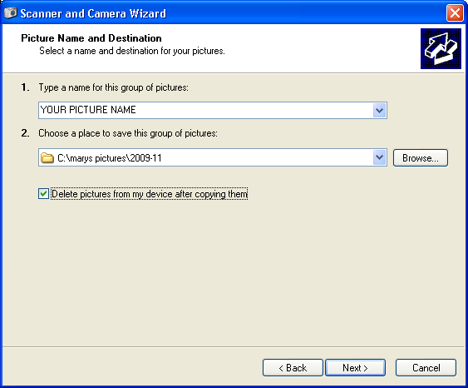

WARNING

REMEMBER TO REPLACE THE MEMORY CARD IN YOUR CAMERA. LOTS OF PHOTOGRAPHERS HAVE FOUND THEMSELVES READY TO SHOOT ONLY TO DISCOVER THAT THEIR MEMORY CARD IS AT HOME IN THE CARD READER.

TIP: AS YOU ARE DOWNLOADING YOUR IMAGES TAKE OUT YOUR BATTERIES AND CHARGE THEM, LEAVE THE CAMERA BESIDE THE CHARGER SO THAT YOU ARE LESS LIKELY TO FORGET YOUR BITS AND PIECES.

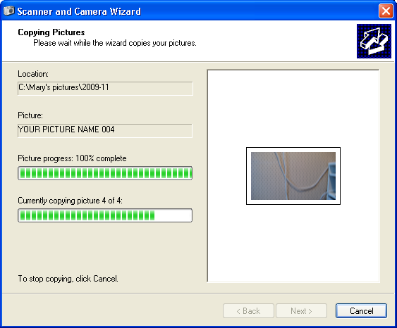

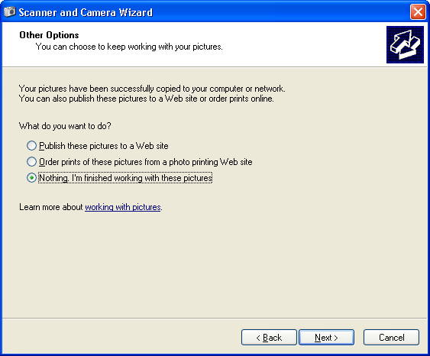
(11) After a few seconds you will see the pictures in the file browser. Click on the first one to highlight it and view it using “Windows picture and fax viewer” Some computers may have a photo editing program which will open the photos by default however for the purpose of this exercise we want to use “Windows picture and fax viewer”. If you have difficulty close everything down by hitting the “X” button on the top right of your screens and when you get back to your desktop click “START” then “MY COMPUTER” then “C DRIVE” (assuming that’s where you created “Mary’s Pictures”), then click on the folder “Mary’s Pictures” then “2009-11” and there you will see your photos.

To make sure your pictures open using “Windows picture and fax viewer”, right click on one picture file name and choose the option “open with” then “choose program” The box below will appear so you can choose “Windows picture and fax viewer”. Click the box marked “always use the selected program to open this kind of file”. This will mean that in future all your JPEG files will be opened automatically with this program. You will of course be able to use other programs to look at your shots but “Windows picture and fax viewer” will always be chosen by “default”.

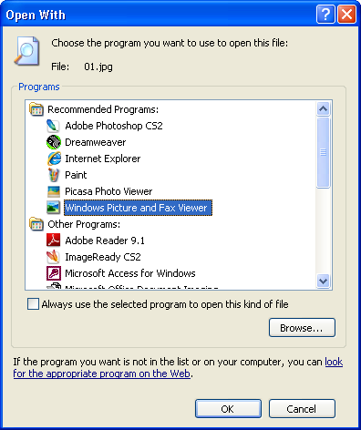

3 - Windows picture and fax viewer

This is a program that comes with Windows XP and is very useful for showing pictures to family and friends. It is NOT an editing program however it has a number of features worth learning.
When you open an image in Windows picture and fax viewer you will notice below the picture are a row of icons as follows:

- Left arrow displays the previous image in the same folder.
- Right arrow displays the next image in the same folder. Note: You can use
the arrows on your keyboard for the same purpose.
- Displays the image as “best fit” on your screen
- Displays the image in it’s true definition, all the image may not fit on the
screen when you activate this.
- Displays the images as a slide show. Each image will be on the screen for
about 5 seconds but there is a facility to pause or reverse this process.
- Magnifier to zoom in.
- Magnifier to zoom out.
- Rotate Clockwise
- Rotate Clockwise
- Delete
- Print
- Copy to
- Open in Paint shop for editing
- Help – See text below

Windows Picture and Fax Viewer overview
An image or picture is a photograph, line drawing, or text document converted to digitized form, usually by a scanning device such as a digital camera, fax machine, or scanner. You can download your images from the device and save them in a folder. After downloading pictures to your computer, you can view them as a slideshow or view them using Windows Picture and Fax Viewer.
Use Windows Picture and Fax Viewer to work with your images without having to open an image editing application. If you store your picture files in the My Pictures folder, you see the preview window automatically. Double-click an image to preview that image in Windows Picture and Fax Viewer, where you can:
- Scroll through the images in the folder.
- Increase or decrease the image preview size.
- View the image in full size or as the best fit for your window.
- Manage image files and print, save, delete, or change file details.
- View a slide show of all your images, or select the set of images you'd like to view in a slide show.
- Open the image in an editing program if you wish. Note that this closes Windows Picture and Fax Viewer.
- Rotate images right or left by 90 degrees.

4 - File Management

Access “MY COMPUTER” by clicking on “START” then on the drive you want to use. 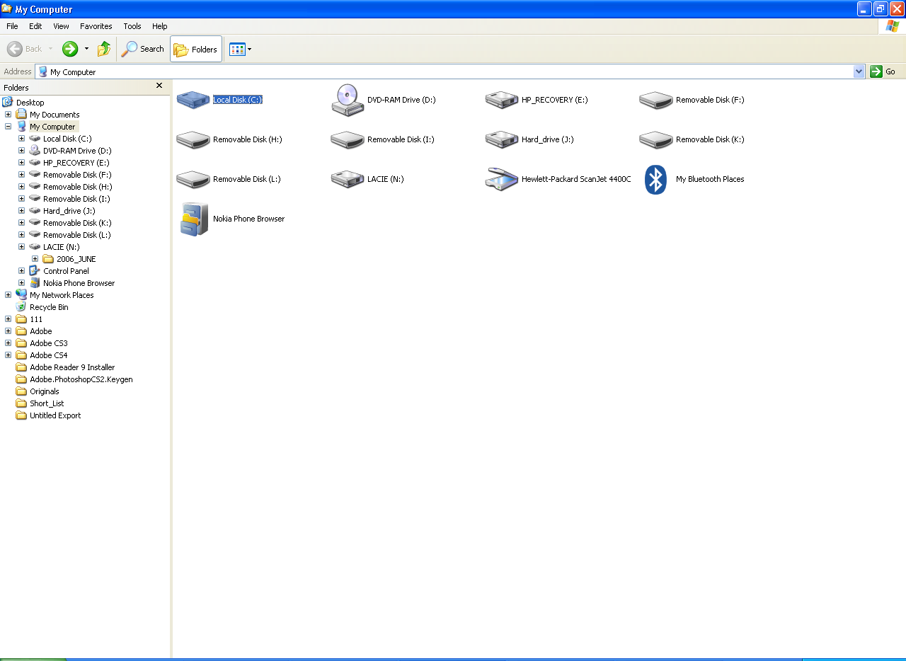
Remember the “C” drive is generally the main storage drive. Click on the Folder that stores
your photos; we called ours “Mary’s Pictures”
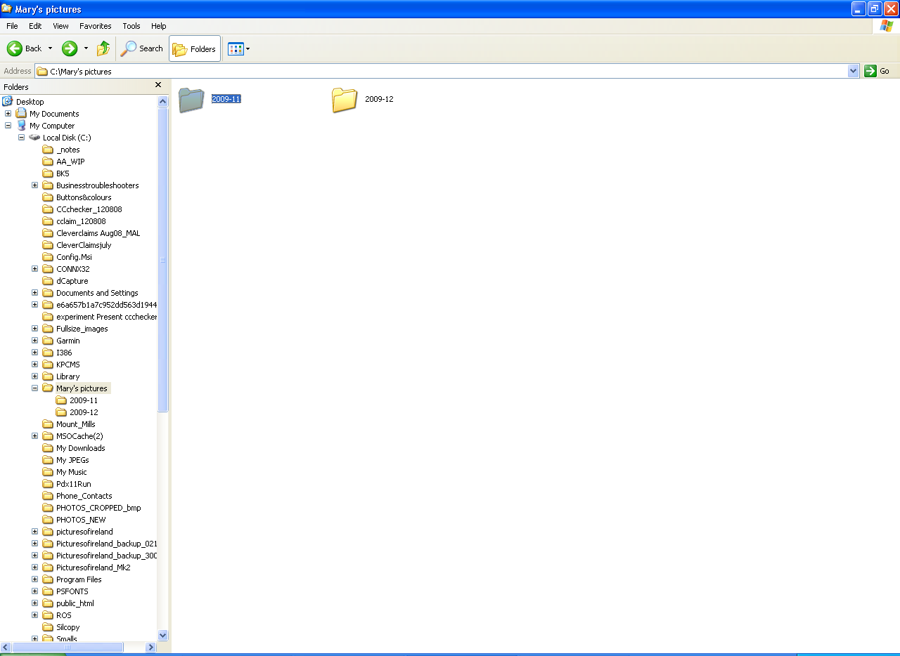

Then click on the sub-folder where your images are kept; we used “2009-11”
This will reveal your picture files called by whatever name you used, I have called mine “Emyvale” so you can see my files carry the name Emyvale plus a number.

Remember your photographs are just files in the computer, they exist in folders and subfolders and can be selected, viewed, moved and copied at will.
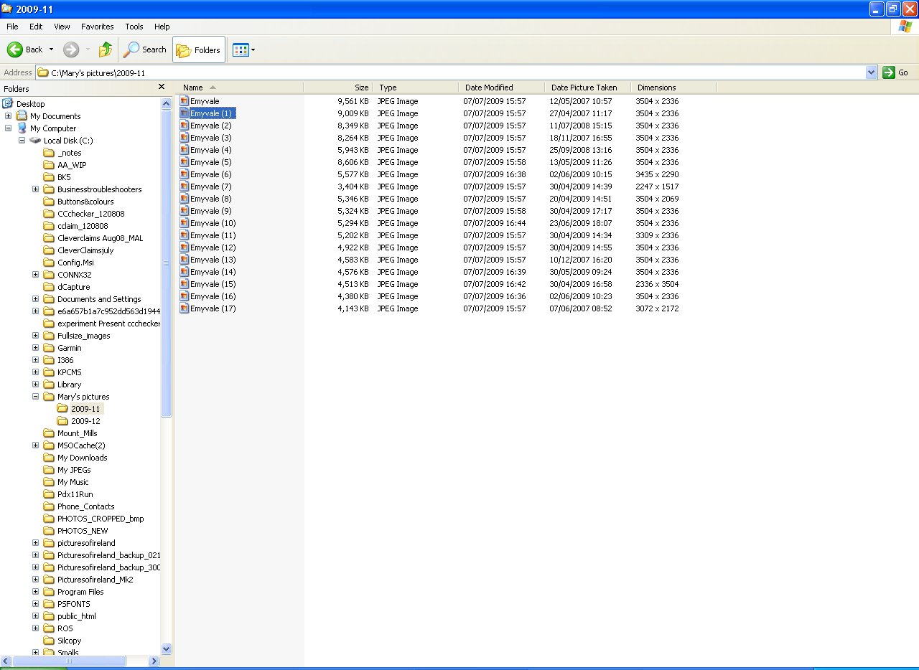

There are 6 ways to view your files you will find these options in your explorer under the option “view” on the top menu bar.
- Filmstrip
- Thumbnails
- Tiles
- Icons
- List
- Details

Have a look at all the options and use the one you feel most comfortable with. I generally use “Thumbnails” and “Details”. “Thumbnails” shows you a little view of your shot whereas “Details” gives a list under the following headings:
- Name
- Size
- Type
- Date Modified
- Date Picture taken
- Dimensions

By clicking on these headings we can list our files in order eg click on the “name” heading and your files will arrange in Alphabetical order A to Z. Click again and they will reverse the order Z to A. Click on “size” and the files will be arranged in order smallest to largest. . Click again and they will reverse the order largest to smallest. This principle applies to all headings in the Windows Explorer. This is one of the reasons I use the YYYY-MM-DD file-naming format as in this way the subfolders automatically appear in date sequence.

Tip: Practice right clicking on your mouse, you will find a lot of easy to understand commands in the drop-down menu that appears.
Selecting files

Often it is necessary to select files for various reasons. Perhaps we need to rename, transfer or delete a bunch of them or email them to friends. Here are two simple ways to grab the files you want.
- If the files you wish to select are in sequence, click on the first one, hold down the “shift” key (that’s the key with the up arrow “⇑” on it, there are usually two on the keyboard one left and one right on the ZXCVBNM line) then click on the last one. All the files in between will turn blue showing that they are selected.
- If the files you wish to select are not in sequence, click on the first one you want, hold down the “control” key (that’s the key with “Clrl” on it, there are usually two on the keyboard one on the bottom left hand corner and one on the bottom right hand corner of the keyboard) and click on the files you wish to select, one by one. If you select one by mistake just click on it again and it will be de-selected.

Renaming your files

Should you wish to rename a file just right-click on the file name and choose the option “rename”. The file name will go blue to indicate that it is in edit mode and you simply type in your new name. Windows Explorer will never allow two files of the same name in the one folder.

Deleting files

We have already learned that we can delete an image as we are viewing it in WINDOWS PICTURE AND FAX VIEWER, but we can easily delete images in the explorer as well by just selecting the file or files (it/they will turn blue) and pressing the delete button on your keyboard. Alternatively you could right-click on the selected file or files and choose “delete” from the dropdown menu. Either way this notice will appear:
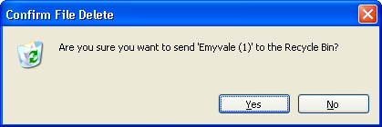
Once you click on “yes” your image has gone to the recycle bin, you can retrieve it from there quite easily but that’s another day’s work.

Moving and copying

The difference between moving and copying is that when a file is “moved” it exists in the new location only. If it is copied it continues to exist in the original location but an exact copy is made in the new location.
To move or copy a file, select the file or files you need and right click on any one of the selected files. Then choose cut or copy. Now go to the folder where you wish the file or copy to end up, highlight that folder, right click and choose the option “paste”.

Properties – Your pictures birth Certificate!

Often we need to find out details about a shot. This is all available in “properties”. To view properties right-click on the image or file name and choose the option – properties. A screen like this will appear:
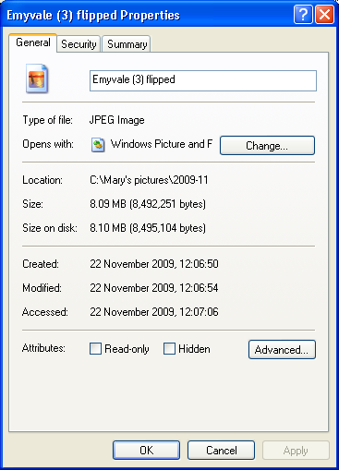

For more details click on the “Summary” tab at the top. A screen like the one below left will appear. Click the “advanced” icon and that will reveal all the details relating to the shot.

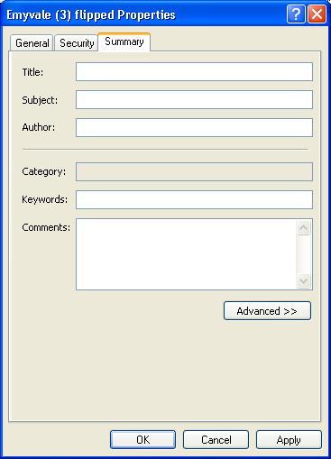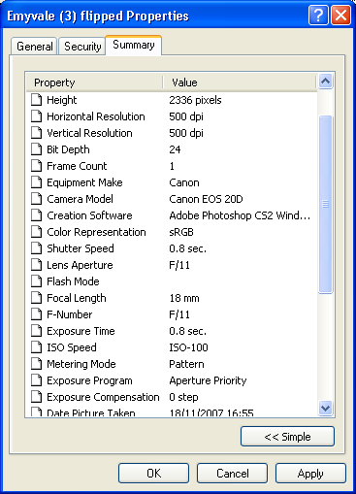

Emailing photos

Like most things on a computer there are loads of ways to do this. We are going to look at one, which I hope you will find easy. Photographs can be transmitted by email in full size if desired. This is good if the recipient needs all the detail or if they are going to print the shot however the transmission time for a large file even with good broadband is long and you may not always know the speed of the recipient’s line. Also the recipient may have difficulty handling a large image, as they may not have the appropriate computer setup. Therefore it is usually preferable to reduce the size and quality of your shots particularly since you have been taught so well to use large file sizes!
Start by selecting the file or files you wish to transmit by email. Right click on the first image and select the “send to” option. This will open up another dropdown menu from which you select the option “mail recipient”. This will open up the screen below offering to resize your photographs. Choose either the smaller or original option and click “OK”
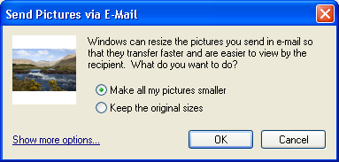
This will open up your email program usually Outlook Express and your email will be there with the photo attached waiting for the recipients address and your message.
Printing options

Printing your own photos is an art in it’s own right which we will cover on another occasion but there are plenty of professional printing establishments that charge very reasonable prices. To reduce the cost we can select for printing only those pictures that we want our friends to see. These professional printers will accept JPEG files in any medium so we must learn how to transport our photo files.

Transporting your photos

Once you have them on your computer your options are open. You could pick out a few favourites and put them back on to your memory card or you can use a memory stick, which will plug into all computers and an increasing number of televisions. Remember we learned that a PC is just a big filing cabinet and that when we plugged in our card reader it appeared as another drive in our explorer so that we could copy our files across. In the same way we can copy files back from our C:\ drive on to any device we care to attach to the machine using the selecting and moving or copying procedure explained a few paragraphs ago.

Burning a CD

Often people like to put their pictures on to a Compact Disk (CD), which are universally accepted by all sorts of devices. Many PCs come with special CD burning programs, which work well and are fully automatic. However here is a basic way to get your photo files on to a CD, it is similar to any other file transfer with one extra step.
- Put a blank CD in to your drive and note it’s location, it’s usually called “D” or “E”.
- Select the files to be transferred.
- Copy or cut the files from their original location.
- Paste them in to the CD drive, this may take up to a minute.
- Right click on your CD drive and choose the option “explore” you’ll see this screen:
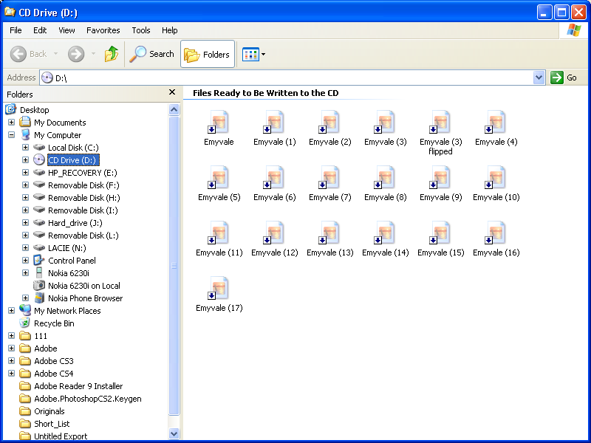
- Right click anywhere around the files and choose the option “Write these files to CD” This will take a few minutes but when the CD is ready it will pop out of the drive.

Links to some websites you may find useful

http://digital-photography-school.com/digital-camera-modes
http://en.wikipedia.org/wiki/F-number
http://photo-edits.com/camera-101/
http://photography.about.com/od/takingpictures/ss/DOF_2.htm
http://www.11thstudio.com/blogs/all-posts/simple-guide-to-aperturef-stop-numbers-and-depth-of-field/
http://www.azuswebworks.com/photography/dof.html
http://www.cambridgeincolour.com/tutorials/depth-of-field.htm
http://www.cheapshooter.com/2007/08/13/9-digital-camera-settings-for-every-photographer-to-discover/
http://www.digital-photography-forbeginners.com/Digital-Camera-Settings.html
http://www.ehow.com/video_4414086_using-point-shoot-cameras.html
http://www.petercox.ie/depth-of-field.php
http://www.photoactive.co.uk/archives/1095
http://www.photography101.org/basics/camera_settings_explained.html
http://www.photoimagenews.com/plumbing.htm
http://www.photoxels.com/digital-photography-tutorials.html

http://www.shutterfreaks.com/Tips/ControllingDOF.html

http://www.twistedtreephoto.com/creative%20controls.html

http://www.youtube.com/watch?v=wh6VFzRCZxI&feature=player_embedded

http://www.youtube.com/watch?v=Dt6AvJ7WZSI&p=95860194F4140301&playnext=1&index=1

