Notes for students in Digital Photography course

Agenda

- Getting the image into your camera

- Introduction

- Establish objectives and levels of expertise

- What is photography

- Exposure – how you camera works

- Focus

- Light metering

- Using flash – avoiding redeye

- Getting the image out of your camera

  - Downloading to a PC or Laptop

  - Viewing your images

  - File management

  - Enhancing and manipulating photographs

  - Transporting images

  - Emailing pictures

  - Burning to a CD

  - Printing a shot

- Composition – What makes a good picture?

- Criticising our work

Getting the image into your camera

In ideal circumstances, with a small group, it would be possible to go around and explain the settings on each individual camera however since it is unlikely that there are two participants at the class with the same model of digital camera that would be time consuming and most probably counter productive.

The old adage applies here, “Give a man a fish and feed him for today but teach a man to fish and feed him for the rest of his life”.

We will therefore try to cover the main aspects of photography and hope that by the end of the course you will be able to read your camera’s manual and understand the terminology used in it. Towards the end of the course we will run through a manual to make sure that everyone is up to speed.

Moreover it is hoped that you will understand how each mode adjusts the settings of your particular camera and how changes to the settings affect the image produced. I have some appendices on the subject that I am happy to share with you.

In digital photography and computer file maintenance there are usually numerous ways of arriving at the same result. For the purpose of this course I have chosen what I consider to be the easiest or most common methods. They are certainly not the only methods so feel free to share with the rest of us the methods you have found useful.

What is photography

Photography is the process, activity and art of creating still or moving pictures by recording radiation on a radiation-sensitive medium, such as a photographic film, or an electronic sensor. Photography uses foremost radiation in the UV, visible and near-IR spectrum. For common purposes the term light is used instead of radiation. Light reflected or emitted from objects form a real image on a light sensitive area (film or plate) or a FPA pixel array sensor by means of a pinhole or lens in a device known as a camera during a timed exposure. The result on film or plate is a latent image, subsequently developed into a visual image (negative or diapositive). An image on paper base is known as a print. The result on the FPA pixel array sensor is an electrical charge at each pixel, which is electronically processed and stored in a computer (raster)-image file for subsequent display or processing. Photography has many uses for business, science, manufacturing, art, and recreational purposes.

In a nutshell

Your camera uses light reflected from the object you are photographing to form an image on the light-sensitive film or sensor in your camera. This is called an exposure and we can determine the quality of the exposure by making simple adjustments to our camera.

Exposure

Most of us find that it is easy to take a good shot on a bright day however since we live under the grey skies of Ulster we need to know how best to set our equipment to obtain a reasonable image in less favourable light even at night.

The fundamentals of photography exposure settings etc. apply to all cameras as a very simple process is used to make a photographic image.

Light passes through a hole in the lens (called an aperture) for a specific amount of time (determined by shutter speed) and makes an image on a light sensitive medium (film or sensor).

The image is then stored in the film or in the case of digital cameras on a memory card usually in JPEG format. A digital image consists of thousands of pixels or building blocks all of which are of a different shade represented by numbers – hence the term digital. If digital pictures are enlarged over 100% the pixels become separated and the image is then said to be pixelated.

A battery, usually rechargeable, powers your camera. Remember to keep your battery charged and your memory card emptied!

Using Auto Mode

Many photographers are happy to leave all the decision making on these settings to the camera’s own AUTO setting and indeed there are compelling arguments why, in certain circumstances, this may be the best course of action, however, since the object is generally to reproduce in image form what the eye is seeing, even in auto mode the photographer should be aware of the settings being used and always remember that the human eye is infinitely more complicated and efficient than the most sophisticated camera.

A proper exposure is a combination of several elements the most important of which are

- Aperture settings - (the size of the hole measured in F Stops)

- Shutter speed - (the length of time the shutter remains open letting the light interact with the medium)

- ISO setting - (the sensitivity of the medium)

- White balance - (adjusting the “temperature” for different light sources).

A good shot is always a compromise of these four elements– aperture settings – shutter speed – ISO setting – white balance.

In automatic mode the camera makes all the decisions. In the “creative modes” the photographer can control some or all of the settings, this is useful (almost a must) to get reasonable shots when light conditions are not ideal.

If too much light gets in the shot will be over-exposed conversely too little light will result in a dark under-exposed image.

Low ISO settings may restrict the use of optimum speed and aperture settings whereas a high ISO number will produce “grain” or “noise” in the image.

Artificial light can play tricks with the tone of your photograph unless the white balance is properly adjusted.

Focusing – what needs to be “sharp”

Most modern digital cameras lock on focus when the shutter button is depressed about half way.

Even in automatic mode be careful where the focal point is, remember that is the point that will be absolutely in focus (“sharp”) as will some distance in front of the focal point and about double that amount behind.

That area called “depth of field” (the amount that is in focus) is determined by the aperture setting used.

Aperture settings

The size of the aperture is measured in “F” numbers sometimes referred to as F-stops. It is rather confusing but important to remember that the higher the F-number the smaller the aperture. Most cameras have aperture settings ranging from F2.8 (widest) to about 8 (narrowest). More expensive models may go from F1.4 to F36 or even higher.

The smaller the aperture the larger the depth of field i.e. more of the picture will be in focus – “from your toe to the horizon” – well maybe not quite! For an in-depth look at the subject of depth of field study the appendix on the subject.

Small apertures require the shutter to remain open longer (slow shutter speed) to get a correct exposure. If the shutter speed is too slow (< 1/50sec) camera shake will spoil the shot unless a tripod or other steadying device is used.

A large aperture (low F-number) is used when we want the subject in focus but the foreground and background out of focus or when the background is not particularly important to the shot. This is called a shallow depth of field and is used for portraits to capture just the face. For sports shots, by using a large aperture and faster shutter speed, fast-moving objects can be captured with less risk of blurring.

Shutter Speed

Shutter speed is measured in seconds and parts of a second e.g. 1/125 means that the shutter remains open for one / one hundred and twenty fifth of a second.

The shutter speed necessary to create the correct exposure is related directly to aperture setting, in that, the shutter speed must be decreased (to let light in for a longer period) as the aperture is made smaller (higher F – number), and increased as the aperture is widened i.e. (lower F – number).

Remember again that a very low shutter speed will most probably lead to camera shake unless you are using a tripod or resting your camera on a solid surface as you shoot.

For sports shots a fast shutter speed is essential. For instance, a car moving at 60 MPH covers 88 feet per second so if you try to take a car travelling at 60 MPH with a shutter speed of 1/100th of a second the car will move .88 of a foot or 10.56 inches whilst the shutter is open. This movement creates a blur on the image.
Objects closer to the camera appear to move faster than those further away so a child running across your shot 10 feet away may show more movement than a racing car 100 feet away. Try photographing a mouse sometime!

ISO setting relates to the sensitivity of the sensor (or film) to light. This is sometimes referred to as “film speed” and the higher the ISO number the faster the film or sensor. In other words the higher the ISO number the more sensitive will your sensor be to light. By raising the sensitivity it is possible to increase the chances of getting a decent shot in bad light.

The downside of a high ISO is that the picture may be a little grainy. Basically, the higher the film speed, the worse the photo quality.

So in bad light increase the ISO number, you will find that this will let you use a higher shutter speed, or a smaller aperture, or dispense with the use of flash, depending on your requirements.

White balance determines the “temperature” (Blue = cold & Red = hot) of a shot and can be set as automatic or manually to counteract discolouration due to artificial lighting etc.

----------------

Sometimes it’s necessary to sacrifice everything (large aperture, high ISO etc.) just to get enough speed for a shot and conversely sometimes we need to use a long exposure particularly in bad light or where we need a very large depth of field.

----------------

Usually the settings your camera is using for these four elements are shown on the screen as the shot is being taken. Experiment with your camera and record the different settings it chooses in different modes and conditions. Once you understand how to use these four settings you will be well on your way to mastering the technicalities of photography.

YOUR CAMERA'S METER

The camera's meter measures the light reflected by the subject. Modern cameras may have 3 or 4 metering patterns. Different makers have different names for these patterns.

I.Matrix Metering - The camera's meter sets exposure based on info from all areas of the frame. This would be the best metering pattern to use for general photography.

2. Centre Weighted Metering - The camera meters the entire frame but assigns greatest importance to an area in the centre of the frame-in the assumption that the main subject is there. This would be ideal for portraits and group shots.

3. Spot Metering - The camera meters a very small and specific area of the frame. This is very useful for ensuring that a subject will be properly exposed even when the background is much brighter or darker - EG - a bright flower with an almost black background.

Light Metering

When taking a picture that is going to have a variety of shades and colours in it’s formation always remember that the camera will adjust the exposure for the area on which it is focused, whether your camera is set to focus on the centre or multi zoned.

The meter will generally give good results but it is no substitute for the human eye. Thus there are certain 'tricky' lighting situations, which can fool camera meters.

The main example is where you have a mixture of very dark and very bright sections in a scene that you are about to photograph. Be careful where you focus! Remember if you have a group of men in black dinner suits and you focus on a white shirt you will under-expose whereas if you focus on a black suit you will over-expose.

Taking shots of large presentation cheques is a real nightmare! Being unsure what to do, the camera's meter tries to average out everything and ends up giving you what is known as 18% grey instead of black or white.

The key to getting the best from your camera is to develop an awareness of when the camera is going to get fooled into giving the wrong exposure.

A scene with a small bright area in a large dark one will render your bright area overexposed. So the solution is to reduce exposure levels.

A scene with large areas of brightness may render your image underexposed e.g. snow. Here the solution is to overexpose.

Exposure compensation or Exposure Value (EV)

In creative modes, ie not automatic, the photographer can adjust a variety of settings manually. Most cameras have an EV button to make exposure compensation settings. Using this you can increase or decrease exposure by as much as 2 or 3 stops in half or third of a stop increments. This adjustment allows you to disagree with and readjust the settings your camera has chosen. It is recommended that you play around with these settings to get the best exposure possible.

Holding Focus

Sometimes it is necessary to have something in the picture in focus, which is not in an area of the shot convenient to a metering spot EG a beautiful mountain scene with flowers in the foreground. Your centre focus may be on a spot several hundred feet away and even though you use a small aperture some of the beauty of the flowers at your nose may be lost.

In this case focus on the flowers, press the shutter half way and holding the focus, re-compose the picture and shoot.

Under these circumstances your background may be a little fuzzy (less noticeable because of the distance) but your foreground will be sharp and dramatic.

Shooting Modes

Most cameras have two or three “shooting modes.

- Single shot. This is the most commonly used mode where the shutter release is pressed half way to focus and then fully depressed to take the shot. Quite often this is done in a single action.

- Continuous shooting. If a camera is set to “continuous shooting” mode it will continue to record images in rapid succession until the shutter button is released.

  - Time release. Using this mode a camera can be set in a shooting position and when the shutter button is pressed a period of time will elapse before the picture is taken. This mode is commonly used to allow the photographer to appear in the shot but it is also useful in long exposure shots to reduce vibration caused by the finger pressing the shutter release button.

Memory cards and image size

Your camera will let you take images in a variety of sizes and qualities. As the size is enlarged and/or the quality setting of the shot is increased the size of the file to be stored on your memory card will increase.

This means that fewer images can be stored so if you are using a card with a small memory you may run out of space.

In general it is always best to shoot at highest quality and maximum size, as this will give better definition and enable you to enlarge the shot or perhaps crop a small part of it while still retaining acceptable image quality.

Use a large memory card and always carry a spare – memory is cheap and you can dump your waste without charge!

Using Zoom

Most digital cameras have some sort of Zoom – that is a mechanism for making objects appear closer. In general it is better to move the camera and object closer together but if that is not possible then zoom is a useful tool. On some cameras zoom can slightly restrict aperture range.

Digital zoom V. Optical zoom
Most cameras specify the total magnification factor that can be provided however this can be misleading, as there are two different types of zoom, digital zoom and optical zoom. In both cases the image is magnified however there is a major variation when it comes to the quality of the reproduced image. Unlike the digital zoom, in case of optical zoom the image clarity is not affected.
Optical Zoom: – Optical zoom works by moving the lens close to the subject and then shooting the picture without sacrificing the picture quality. The higher the optical zoom of a digital camera the farther you can move away from the subject yet still take close-up images.

Digital Zoom: – In case of digital zoom the camera lens is not moved closer to the subject, but a section of the image is cropped by the camera and then digitally magnified to fit the viewfinder portion. This adversely affects the image quality. There is no gain of any additional image detail when digital magnification is used.

The benefits and shortcomings of flash

To flash or not to flash, that is the question! Flash can be a useful source of light when no other is available or to fill in dark shadows when shooting into the light, however, it is somewhat limited.

Most compact cameras have a flash that is likely to light a semi circle of about 3 to 4 metres radius, objects outside that area will be dark and underexposed and it is possible that objects nearest the camera lens may be overexposed.

Ask yourself; do I really need to use flash? Will the flash bouncing off a shiny surface e.g. a mirror or even a bald head ruin my picture? Can I get a reasonable shot by altering my settings to make use of available light? Could I use a higher ISO perhaps?

In some situations the use of flash may be forbidden e.g. churches museums etc. And then there’s the dreaded RED EYE.

Red-eye; what causes it and some tips to prevent it.

It can be very frustrating to find an otherwise excellent photo ruined by the subject having red eye.

Red eye is caused by your digital camera’s built-in flash. Unfortunately, in most compact digital camera’s the flash is positioned directly beside the lens, so the light from the flash bounces off the subject’s eyes and back to the camera’s lens, resulting in those evil-looking red eyes.

Here’s a quick science lesson for you. The coloured part of your eye, called the iris, controls the levels of light which enter the eye by dilating and constricting the black center of your eye, called the pupil. Its function is very much like the lens aperture of a camera.

When a flash on a camera is used, the light disperses so quickly that the iris doesn’t have time to constrict the pupil before the photo is taken. The result is this: the light travels through the choroid (which consists of layers of blood vessels), hits the retina (which lines the back of the eye) and bounces back through the blood-rich choroid and through the iris.

The camera captures this light reflection ultimately resulting in the red eye effect.

Many compact digital cameras have “red eye reduction” which can help a little. This works by making the flash unit emit a strong light immediately prior to the flash. The idea is that the bright light will cause the iris to react and constrict the pupil before the flash goes off. The results are only partially successful and often you will have to resort to fixing up your red eye problem on your editing program.

Remember the brighter the lighting the less likely you are to experience red eye, as the subject’s pupil will already be quite constricted. Sometimes it is useful to ask the subject to stare at a bright light for a second or two immediately before the flash shot is taken.

----------------

In the attached appendices you will find an explanation of terms used in most camera manuals, which I think you will find to be of use. I have copied these appendices from various sources, modified and compiled them in what I hope is an easy-to-read format. On the next page you will find a list of website addresses which may interest you.

Copyright 2010
Malcolm Totten
Mullaghmore West
Ballinode
Co. Monaghan
www.picturesofireland.ie
Links to some websites you may find useful

http://digital-photography-school.com/digital-camera-modes
http://en.wikipedia.org/wiki/F-number
http://photo-edits.com/camera-101/
http://photography.about.com/od/takingpictures/ss/DOF_2.htm
http://www.11thstudio.com/blogs/all-posts/simple-guide-to-aperturef-stop-numbers-and-depth-of-field/
http://www.azuswebworks.com/photography/dof.html
http://www.cambridgeincolour.com/tutorials/depth-of-field.htm
http://www.cheapshooter.com/2007/08/13/9-digital-camera-settings-for-every-photographer-to-discover/
http://www.digital-photography-forbeginners.com/Digital-Camera-Settings.html
http://www.ehow.com/video_4414086_using-point-shoot-cameras.html
http://www.petercox.ie/depth-of-field.php
http://www.photoactive.co.uk/archives/1095
http://www.photography101.org/basics/camera_settings_explained.html
http://www.photoimagenews.com/plumbing.htm
http://www.photoxels.com/digital-photography-tutorials.html

http://www.shutterfreaks.com/Tips/ControllingDOF.html

http://www.twistedtreephoto.com/creative%20controls.html

http://www.youtube.com/watch?v=wh6VFzRCZxI&feature=player_embedded

http://www.youtube.com/watch?v=Dt6AvJ7WZSI&p=95860194F4140301&playnext=1&index=1

http://www.videojug.com/interview/adjusting-your-digital-cameras-exposure

A Primer on Depth-of-Field — Ensuring Everything You Want is in Focus
Of all the topics I cover in my workshops, I find that depth-of-field is the one that tends to confuse people the most. Using it properly is one of the fundamental skills a good photographer must master.
What follows is a slightly simplified explanation of depth-of-field and focus. I have not taken camera movements into account as most people reading this won't be using such techniques. It will suffice to give a good working knowledge of the concepts to someone who is just being introduced to them.
What is depth-of-field (DOF, for short)? The definition is as follows:
"The portion of the scene — both in front of and behind the plane of focus — that is considered to be acceptably sharp."

The Basics of Focus
Clearly, in order to understand DOF, we must first undestand focus. When we focus on an object with our camera, we are aligning the lens so that that particular distance from the camera is in focus. Therefore, anything at that distance from the camera will be in focus, whether it's above, below or to either side of the object we focused on initially.
"When an object is in perfect focus, light rays from a point on that object — or any other at the same distance — will converge to a point on the camera's sensor."
The above statement tells us that in any photograph, only objects at that specific distance are truly in focus. This is referred to as the focal plane. Any objects in front of or behind the focal plane will be out of focus. The illustration below shows this.
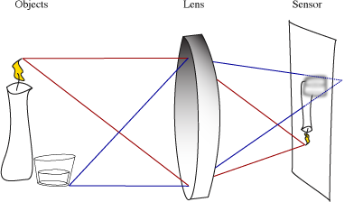
You can see here that the red rays coming from the candle converge back to a point on the sensor, resulting in a sharp image of the candle. However, the blue rays, coming from the glass, converge behind the sensor, resulting in an out-of-focus image of the glass. This is because the glass is in front of the candle and therefore at a different distance.
So if we can't have objects that are not in focus be, well, in focus - how do we make photographs where everything is sharp from the photographer's feet to the distant horizon? The answer is in exploiting the fact that our eyes have limited resolving power - they're not perfect.

Circles of Confusion
In the illustration above, the blue rays don't converge to a point on the sensor - they converge behind it (the dotted lines show their path if they were able to continue beyond the sensor). This means that instead of describing a point on the sensor, they describe a disc instead. These discs are known as circles of confusion. Any out of focus object will be projected as a mass of these overlapping discs - that's why an object that's not in focus looks blurry.
It is in managing the size of the circles of confusion in out-of-focus areas that we're able to create this illusion known as depth-of-field. The way we do this is by varying the size of the aperture in the lens.

The Aperture
All camera lenses have a variable aperture. This is simply an opening in the lens through which the light is permitted to pass. We can make it bigger or smaller to suit our needs, and through that we can manage the DOF in an image.
In the illustrations below, light rays from an out-of-focus object are being directed through the lens and onto the sensor. In the first, a large aperture is used, and in the second, a smaller one. Nothing else has changed - the object is equally out of focus in both examples.
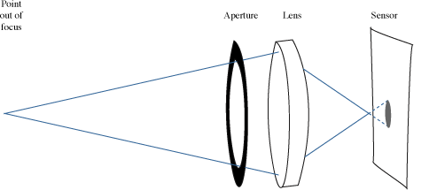
In the first example (above), the gray spot on the sensor is the circle of confusion created by this out of focus point. You can see that it's quite large, which means it will be obviously unsharp to the viewer.
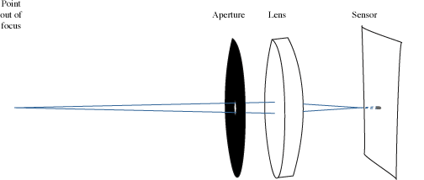
In the second example, the gray spot is far smaller, and to the viewer may appear sharp (depending on how large the photograph was printed). It's smaller because the aperture was smaller, and therefore forced the light rays from our point to enter at a shallower angle. They still converged on the same point in front of the sensor, and then diverged again. However, unlike the first example, they weren't able to diverge very far before striking the sensor and making the image.
It's precisely this behaviour that creates the illusion of depth-of-field.

In a Print
Again, the whole idea of depth-of-field is to trick the viewer into seeing something that's out of focus as being sharp. We do this by ensuring the circles of confusion of out of focus areas are so small that they are indistinguishable from a point.
This works very well in small prints. However, when enlarging your photographs, the larger the final size, the more likely it is that the viewer will start to see the out of focus areas as being unsharp. Therefore, it's essential to take care when making the photograph to ensure that you use a sufficiently small aperture to have everything appear sharp, even in a large print.

In the Field
How do you put this into practice? Well, where you want to isolate a subject and make it stand out from the background, such as with a portrait, you would use a large aperture. Because the circles of confusion are larger, out of focus areas will very quickly become unsharp, as below.
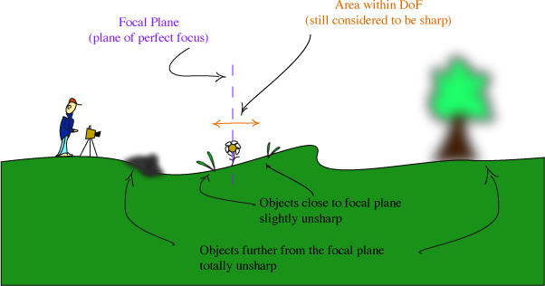
Where you want to have sharpness from front to back, such as with most landscape photography, you want to use a much smaller aperture. Because the circles of confusion are smaller, they appear sharp to the eye. If done properly, this will work even in a large print, as below.
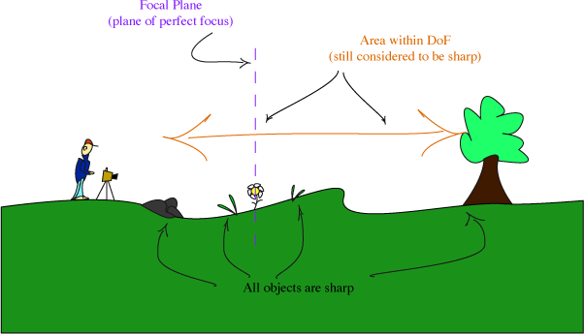

Examples
Here are two examples. The first, an image of a great skua chick, was made with a telephoto lens and a large aperture of f/5.6.
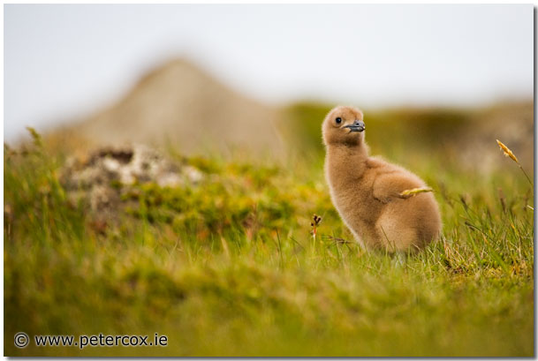
You can see that the chick itself is perfectly sharp, but the grass in front and behind it is increasingly unsharp.
In the example below, a tiny aperture of f/22 was used to ensure sharpness from front to back.
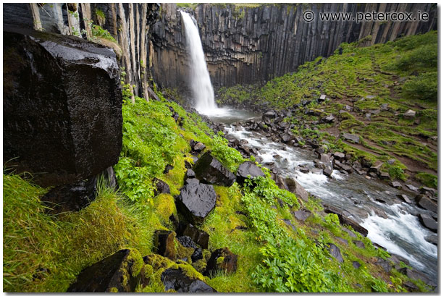
Note that both the rocks behind the waterfall and the rocks and foliage in the foreground are sharp.

In Conclusion
Understanding how to control depth-of-field is critical to your growth as a photographer. It requires a little practise and some knowledge of theory to get it consistently right, but it's well worth the investment in time and effort.

Vital Statistics

Aperture, shutter speed and focal length are a camera’s vital ingredients, and each combines to produce your picture. The same is true of digital cameras though the way these are expressed can be different.

An exposure is the result of two factors: the speed at which the camera’s shutter opens and closes; and the width of the aperture through which light passes. The same is true whether you’re using a conventional or digital camera. Shutter speeds are usually measured in fractions of a second: 1/30th, 1/60th, 1/125th, 1/150th and 1/500th. Aperture is measured in f-stops: f/2.8, f/4, f/5.6, f/8, f/16. Each stop admits half the light of the previous setting.

A slow shutter speed allows more time for the light that is passing through the aperture to reach the CCD (charged-couple device). Similarly, a wider aperture allows more light to pass through. It follows that combinations of the two enable the same amount of light to reach the CCD.

With many mid- to high-end digital cameras, the photographer has complete control over the way these two factors are combined to produce a picture, and all but the most basic digital cameras offer some degree of control. The question is, why and when to favour aperture over shutter, or shutter over aperture? The answer lies in depth of field and movement. A narrow aperture allows more of the picture to be in focus. That is, a picture exposed at say 1/60th of a second and f16 will focus everything between a metre and infinity (described as ‘depth of field’), ideal for landscapes. But 1/60th is slow, and if there’s movement in the scene it could be blurred.

Light, Camera …Action!

So when taking an ‘action’ photo a fast shutter speed of say, 1/500th of a second, and a correspondingly wider aperture of perhaps f/2.8 are used. This allows enough light to enter the camera for your subject to be in focus, while other details will be blurred.

What does all this mean to digital cameras, which have a CCD rather than a shutter? Much the same, a digital camera fired at 1/500th of a second makes an exposure just like a conventional camera. The difference is that the CCD is turned on and off for 1/500th of a second rather than the plates of a shutter passing across a film frame. The control you have over the aperture settings of digital cameras depends on the camera. Mid-range cameras allow manual aperture settings, but most have a ‘motion’ setting for taking action photographs.

Camera Settings Explained
Photography Basics > Camera Settings Explained
Whether you have a point and shoot camera or a digital SLR, you may find that you have many of the same settings. Understanding these settings and how they work is one of the fundamentals of photography. Without this knowledge, you will never be able to take your shots to the next level that custom settings offer. One of the most critical mistakes beginner photographers make is using the 'Auto' modes on their cameras. While this is fine for simple snapshots, actual photography requires much more.

Camera Modes
There are several different 'modes' on your camera that determine the level of automation which your camera will provide. These modes are generally adjusted by a dial located on top of your camera, and may range from fully manual, meaning you have control over every single aspect of the shot, to fully automatic, meaning the camera will control everything for you based on the current conditions.
There are two categories (or 'zones') of modes, Basic (automatic) and Creative (manual), each of these zones make up half of the dial. Most dials have 'Fully Automatic' mode in the very center of the dial, marked by a green square. Basic modes are marked by icons which represent the primary use of that particular mode, and are generally accessed by turning the dial clockwise from fully automatic mode. Creative modes are marked simply by letters, and are generally accessed by turning the dial counter-clockwise from fully automatic mode.
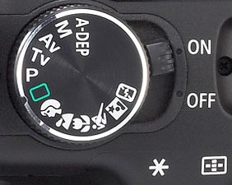
Mode dial on the Rebel XT. Above the fully automatic mode is the creative zone, below it is the basic zone.

Basic Zone (Auto Modes)
Modes which are typically located in the basic zone, but will vary depending on camera. Many cameras will not have all of these modes.
Pan Focus Mode - An assisted focus mode for shots in which there is a lot of movement or action, making focusing (either manual or auto) difficult. This sets the camera at the widest possible focal point to attempt to focus on the whole scene. (Not shown on example picture)
Portrait Mode - Icon: A side (profile) view of a head. - This mode brings subjscts in the foreground into sharp focus, and may enlist the use of a larger aperture to blur the background.
Landscape Mode - Icon: Mountains. - This mode is for taking shots of distant objects, or wide-angle shots, and will bring background objects more clearly into focus by setting a smaller aperture.
Night Scene Mode - Icon: Icon containing a star. - This mode uses flash and a slower shutter speed to illuminate the subject and allow more light to enter the camera.
Black and White Mode - Used to take pictures in black and white, which is arguably not very useful, as you can always take a picture in color and convert it to black and white later using image editing software, which offers more versatility. (Not shown on example picture)
Macro Mode - Icon: Flower. - Used for extreme close-up shots where the camera may have trouble focusing in other modes.
Sports / Action Mode - Icon: Running person. - Use this mode for shots in which there is a good amount of motion which you want to capture without blurring.
Movie Mode - Used to shoot low-quality movie clips on point and shoot digital cameras (this mode is not available on DSLR cameras due to the method of action which they use). Mainly a novelty mode, it can not be expected to produce anything of worthwhile quality. (Not shown on example picture).

Creative Zone (Manual Modes)
Modes which are located in the manual zone, and offer greater control and fine-tuning of your shots.
Program Mode (P) - Much like an automatic mode, the camera will still do the majority of work for you, but offers you the option to manually override settings such as focus, while the camera manages the exposure. Program mode is decent for beginners who want to be able to get quick shots without putting too much thought into it, but still want a bit more versatility than an auto mode offers.
Shutter Priority (TV) - In shutter priority mode, you are able to manually adjust the shuter speed while the camera controls the aperture and ISO.
Aperture Priority (AV) - Aperture priority mode is similar to shutter priority mode, but lets you adjust the aperture, while the camera controls shutter speed and ISO.
Manual Mode (M) - This mode provides the most control of all, as you are able to adjust every aspect of the shot. There is absolutely no camera assist in this mode. You are able to adjust aperture, shutter speed, and ISO for yourself. Most experienced photographers will exclusively use manual mode due to the level of customization it offers.
Auto Depth of Field Mode (A-DEP) - A-DEP is a mode exclusive to Canon cameras, and will measure the depth of the nearest and furthest objects in the viewfinder when the shutter release is pressed half-way, and therefore is able to compose a shot with no blurring of the foreground or background objects which you focus on. A-DEP is complicated to use and generally not worth even attempting.

Shutter speed, ISO, Aperture... oh my!

What is exposure? Exposure is a combination of 3 factors which determine the amount of light which enters your camera. These factors are aperture, ISO, and shutter speed. Photography is all about light, and without an ample amount of light entering your camera, you have nothing but a dark worthless picture. Learning how to determine the right combination of these three settings can be a tedious task, but understanding what they do will make it much easier.

Shutter Speed

Shutter speed is simply how long your camera's shutter stays open when you take a picture. These speeds can range from thousandths of a second to 30 or more seconds. The longer your shutter stays open, the more light your camera lets in. A shutter speed of 1 second lets in 4 times the light of a shutter speed of 1/4 second. The shutter speed can also determine the clarity of a picture. A longer shutter speed will blur the shot, and create trails from even the slightest bit of movement in your picture, whereas a shorter shutter speed will 'freeze' any action and create a sharp picture in which time appears to be stopped. For an example, take a picture of a constant drip of water using both a fast and a slow shutter speed. The shot taken with the slow shutter speed will create a soft blur of water, whereas the shot taken with the faster shutter speed will catch every individual drop in mid-air.
A fast shutter speed can also help eliminate blur due to camera shake when not using a tripod.

Aperture (f/stop)

Aperture (also known as f/stop) is how large the iris (or eye) of your lens opens up. A larger aperture means a larger opening in your lens for light to pass through. When referring to aperture, a smaller number is always a larger opening. For example, an aperture of f/5.6 is a larger opening, and therefore lets more light in, than an aperture of f/11. Each unit of measurement in aperture is called a 'stop' one stop up would be making the lens opening larger, and one stop down would be making it smaller. A single stop down of aperture lets half the light in that the previous stop did.
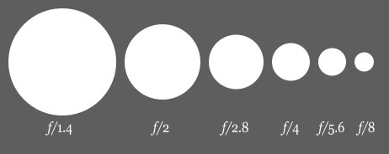
Comparison of the diameter of different f/stops.
Adjusting aperture also changes your Depth of Field. Depth of field is how much of the area, measuring away from your camera, is in focus. If you are tightly focused on an object which is relatively flat, you have short depth of field. If you are focused on a group of people standing at varying distances, you would need a long (or large) depth of field. Basically, a short depth of field (which would be caused by a large aperture) will be clearly focused on a relatively shallow area. The item you focus on may be sharp and clear, but any objects in the foreground or background may be blurred. A smaller aperture would create a larger depth of field, and bring all objects into perfect focus.
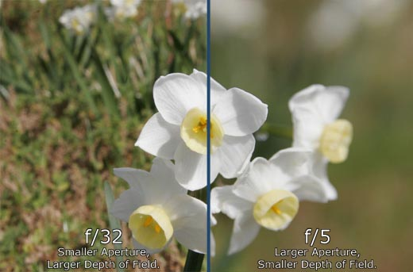

Film Speed (ISO)

Film speed (or ISO) is a measurement of how sensitive your camera's sensor (or in the case of a film camera, your camera's film) is to light. The larger the ISO (higher number), the more sensitive it is to light. The smaller the ISO (smaller number), the less sensitive it is to light. Each step up in ISO doubles the amount of light sensitivity (ISO 400 is 2x as sensitive to light as ISO 200). Using a higher ISO, you can sometimes get shots in low light that would have required a longer shutter speed or a larger aperture if you were using a lower ISO. However, this does not come without its setbacks. The higher the ISO is set, the grainier your picture will appear. At higher ISOs, you will notice some extremely substantial grain. ISO noise is much less noticable in DSLR and other large sensor cameras than it is in point and shoot cameras.
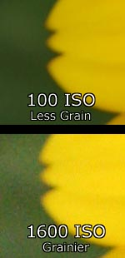
Below are some general ISO guidelines that you can follow.
100 ISO - Less grainy, good for shots with plenty of light.
200 ISO - Still not very grainy, don't need as much light as ISO 100. Grain will be more noticable when printed in larger formats.
400 ISO - Mainly used for shooting lower-light outdoors or indoors without a flash, but with an ample amount of light. Slightly more grainy than ISO 200, but not by much.
800 ISO - Very grainy, but will give 8x the light sensitivity of ISO 100.

Digital Camera Modes
by Darren Rowse
4
del.icio.us
Twitter
StumbleUpon
Digg
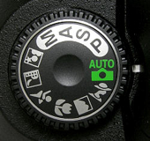
This week I did an informal survey on a few of my digital camera owning friends and asked them to nominate which shooting modes that they most commonly use on their digital cameras (they use a range of point and shoot and DSLR digicams).
The results of this little survey didn’t really surprise me – Automatic Mode was the overwhelming response from both beginner and the more advanced users alike (a little surprising to me). In fact three of the people I questioned responded by asking ‘is there any other non Automatic mode?’
As a result I’ve decided to take a run through the basic shooting modes that most digital cameras have (both point and shoot and DSLRs have most of these).
While this is pretty basic information for many readers I hope it will be helpful for those right at the beginning of their digital photography journey who are yet to venture out of Automatic Mode.

Automatic Modes

Automatic Mode
I suspect no one will need any introduction to this mode (as it seems most digital camera owners use it). Auto mode tells your camera to use it’s best judgement to select shutter speed, aperture, ISO, white balance, focus and flash to take the best shot that it can. With some cameras auto mode lets you override flash or change it to red eye reduction. This mode will give you nice results in many shooting conditions, however you need to keep in mind that you’re not telling your camera any extra information about the type of shot you’re taking so it will be ‘guessing’ as to what you want. As a result some of the following modes might be more appropriate to select as they give your camera a few more hints (without you needing to do anything more).

Portrait Mode

When you switch to portrait mode your camera will automatically select a large aperture (small number) which helps to keep your background out of focus (ie it sets a narrow depth of field – ensuring your subject is the only thing in focus and is therefore the centre of attention in the shot). Portrait mode works best when you’re photographing a single subject so get in close enough to your subject (either by zooming in or walking closer) so that your photographing the head and shoulders of them). Also if you’re shooting into the sun you might want to trigger your flash to add a little light onto their face.

Macro Mode
Macro mode lets you move your closer into your subject to take a close up picture. It’s great for shooting flowers, insects or other small objects. Different digital cameras will have macro modes with different capabilities including different focussing distances (usually between 2-10cm for point and shoot cameras). When you use macro mode you’ll notice that focussing is more difficult as at short distances the depth of field is very narrow (just millimeters at times). Keep your camera and the object you’re photographing parallel if possible or you’ll find a lot of it will be out of focus. You’ll probably also find that you won’t want to use your camera’s built in flash when photographing close up objects or they’ll be burnt out. Lastly – a tripod is invaluable in macro shots as the depth of field is so small that even moving towards or away from your subject slightly can make your subject out of focus. (I’ll write a full tutorial on Macro Photography in the coming weeks).

Landscape Mode

This mode is almost the exact opposite of portrait mode in that it sets the camera up with a small aperture (large number) to make sure as much of the scene you’re photographing will be in focus as possible (ie it give you a large depth of field). It’s therefore ideal for capturing shots of wide scenes, particularly those witch points of interest at different distances from the camera. At times your camera might also select a slower shutter speed in this mode (to compensate for the small aperture) so you might want to consider a tripod or other method of ensuring your camera is still.

Sports Mode
Photographing moving objects is what sports mode (also called ‘action mode’ in some cameras) is designed for. It is ideal for photographing any moving objects including people playing sports, pets, cars, wildlife etc. Sports mode attempts to freeze the action by increasing the shutter speed. When photographing fast moving subjects you can also increase your chances of capturing them with panning of your camera along with the subject and/or by attempting to pre focus your camera on a spot where the subject will be when you want to photograph it (this takes practice).

Night Mode
This is a really fun mode to play around with and can create some wonderfully colorful and interesting shots. Night mode (a technique also called ’slow shutter sync’) is for shooting in low light situations and sets your camera to use a longer shutter speed to help capture details of the background but it also fires off a flash to illuminate the foreground (and subject). If you use this mode for a ’serious’ or well balanced shot you should use a tripod or your background will be blurred – however it’s also fun to take shots with this handheld to purposely blur your backgrounds – especially when there is a situation with lights behind your subject as it can give a fun and experimental look (great for parties and dance floors with colored lights).

Movie Mode

This mode extends your digital camera from just capturing still images to capturing moving ones. Most new digital cameras these days come with a movie mode that records both video but also sound. The quality is generally not up to video camera standards but it’s a handy mode to have when you come across that perfect subject that just can’t be captured with a still image. Keep in mind that moving images take up significantly more space on your memory storage than still images.
Other less common modes that I’ve seen on digital cameras over the past year include:
- Panoramic/Stitch Mode – for taking shots of a panoramic scene to be joined together later as one image.
- Snow Mode – to help with tricky bright lighting at the snow
- Fireworks Mode - for shooting firework displays
- Kids and Pets Mode – fast moving objects can be tricky – this mode seems to speed up shutter speed and help reduce shutter lag with some pre focussing
- Underwater Mode – underwater photography has it’s own unique set of exposure requirements
- Beach Mode – another bright scene mode
- Indoor Mode – helps with setting shutter speed and white balance
- Foliage Mode - boosts saturation to give nice bold colors

Semi Automatic Modes

Aperture Priority Mode (A or AV)
This mode is really a semi-automatic (or semi-manual) mode where you choose the aperture and where your camera chooses the other settings (shutter speed, white balance, ISO etc) so as to ensure you have a well balanced exposure. Aperture priority mode is useful when you’re looking to control the depth of field in a shot (usually a stationary object where you don’t need to control shutter speed). Choosing a larger number aperture means the aperture (or the opening in your camera when shooting) is smaller and lets less light in. This means you’ll have a larger depth of field (more of the scene will be in focus) but that your camera will choose a slower shutter speed. Small numbers means the opposite (ie your aperture is large, depth of field will be small and your camera will probably choose a faster shutter speed).

Shutter Priority Mode (S or TV)
Shutter priority is very similar to aperture priority mode but is the mode where you select a shutter speed and the camera then chooses all of the other settings. You would use this mode where you want to control over shutter speed (obviously). For example when photographing moving subjects (like sports) you might want to choose a fast shutter speed to freeze the motion. On the flip-side of this you might want to capture the movement as a blur of a subject like a waterfall and choose a slow shutter speed. You might also choose a slow shutter speed in lower light situations.

Program Mode (P)
Some digital cameras have this priority mode in addition to auto mode (in a few cameras Program mode IS full Auto mode… confusing isn’t it!). In those cameras that have both, Program mode is similar to Auto but gives you a little more control over some other features including flash, white balance, ISO etc. Check your digital camera’s manual for how the Program mode differs from Automatic in your particular model.

Fully Manual Mode

Manual Mode
In this mode you have full control over your camera and need to think about all settings including shutter speed, aperture, ISO, white balance, flash etc. It gives you the flexibility to set your shots up as you wish. Of course you also need to have some idea of what you’re doing in manual mode so most digital camera owners that I have anything to do with tend to stick to one of the priority modes.
Enjoy this tutorial on Digital Camera Modes? Get more free tips by subscribing to Digital Photography School.
Read more from our Cameras and Equipment Category

Darren Rowse is the editor and founder of Digital Photography School. He lives in Melbourne Australia and is also the editor of the ProBlogger Blog Tips and TwiTip Twitter
Read more: http://digital-photography-school.com/digital-camera-modes#ixzz0WfwcaMKc
Read more: http://digital-photography-school.com/digital-camera-modes#ixzz0WfwcaMKc

